**DAILY ONLINE ACTIVITIES SUMMARY**

|  |  |  |  |  |  |  |  |
| --- | --- | --- | --- | --- | --- | --- | --- |
| **Date:** | **17-07-2020** | | | | **Name:** | **B.A.SOHANKUMAR** | |
| **Sem & Sec** | **4TH SEM A** | | | | **USN:** | **4AL18CS013** | |
| **Online Test Summary** | | | | | | | |
| **Subject** | | **DATA COMMUNICATION** | | | | | |
| **Max. Marks** | | **30** | | **Score** | | **NOT DECLARED** | |
| **Certification Course Summary** | | | | | | | |
| **Course** | **PREDICTIVE MODELLING AND ANALYTICS** | | | | | | |
| **Certificate Provider** | | | **GLA** | **Duration** | | | **5.5 HOURS** |
| **Coding Challenges** | | | | | | | |
| **Problem Statement:----** | | | | | | | |
| **Status:----** | | | | | | | |
| **Uploaded the report in Github** | | | | **YES** | | | |
| **If yes Repository name** | | | | **https://github.com/sohannaik5648987/DAILY-REPORTS** | | | |
| **Uploaded the report in slack** | | | | **YES** | | | |

DESCRIPTIVE TEST DETAILS:

Today there was a test on module 2 and 3 of DATA COMMUNICATION.The duration of the test was 45minutes from 09.30am to 10.45am.Questions were given and we have to write in a4 size sheet and upload it into Google classroom.Score was not declared.

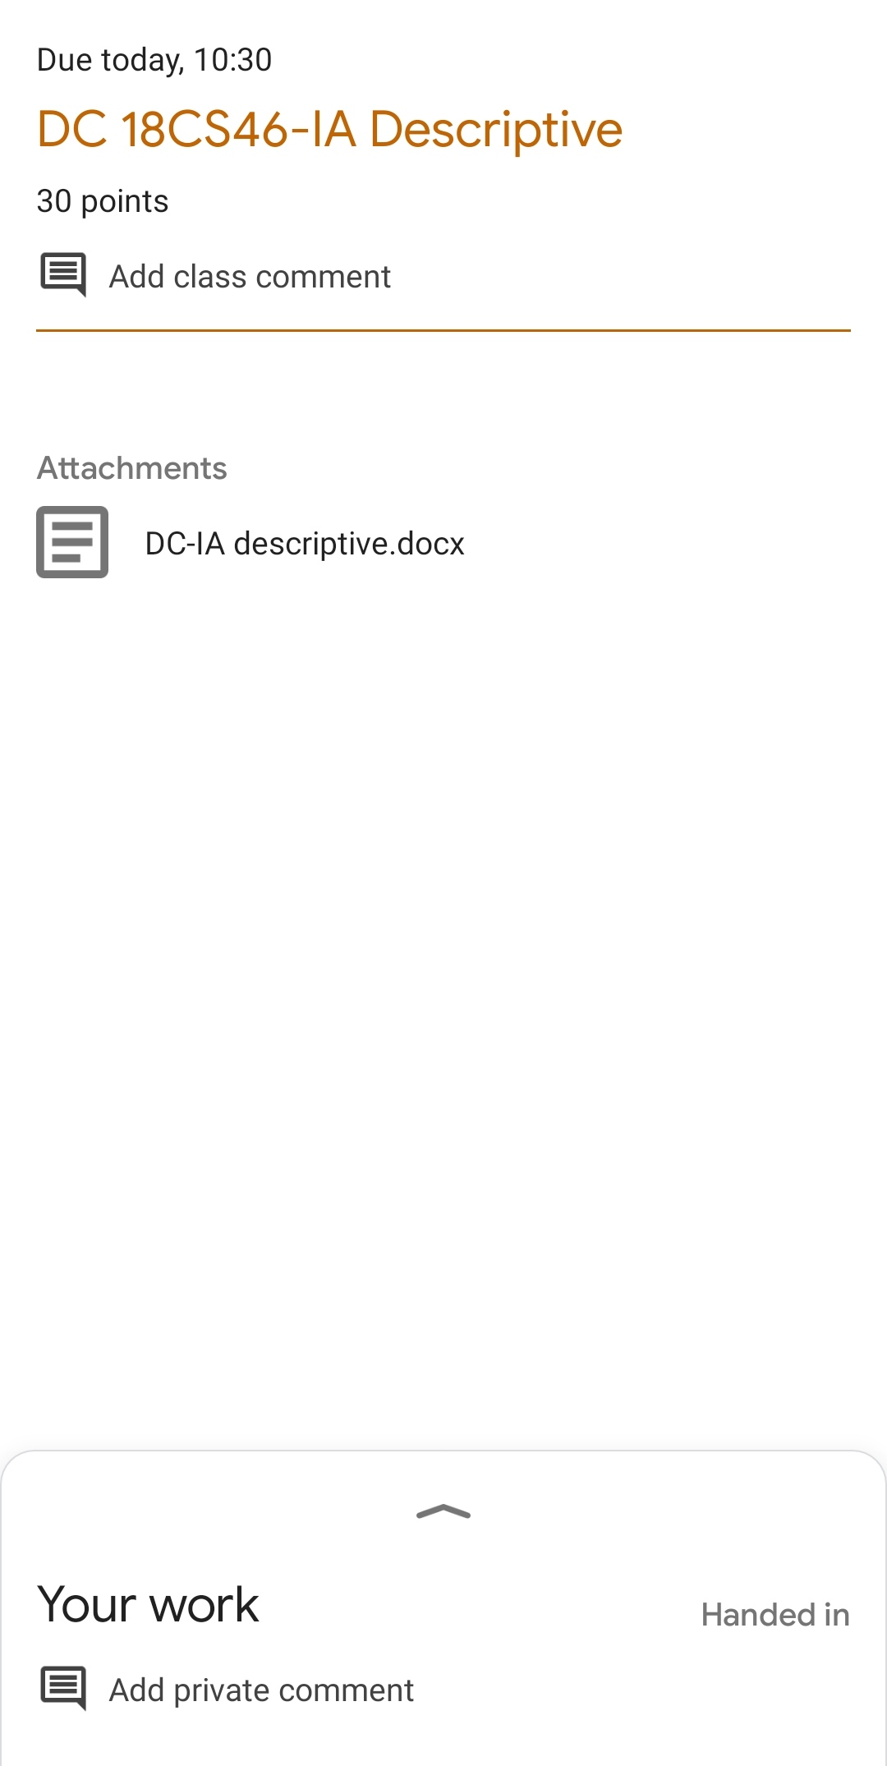

CERTIFICATION COURSE DETAILS:

Course:PREDICTIVE MODELING AND ANALYTICS

Completed modules today are 2.1 - Predictive Modeling-Classification Techniques,2.2 - Logistic Regression-3,2.3 - Logistic Regression - Hands-on,3.1 - Discriminant Analysis,3.2 - Bayes' Theorem,3.3 - Naive Bayes,3.4 - KNN,3.5 - Discriminant Analysis Hands-on,3.6 - Hands-on Naive Bayes,3.7 - Hands-on KNN.

